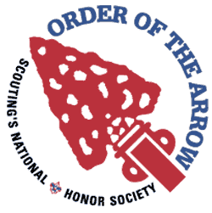
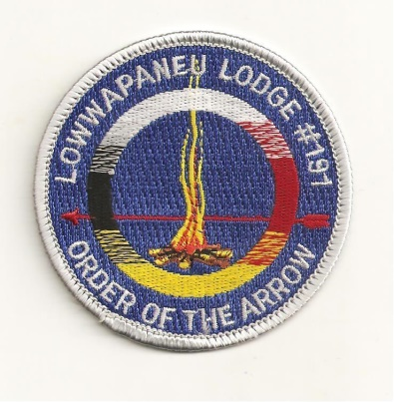
Lowwapaneu Lodge 191 - Section NE - 5
LEC Minutes
September 28, 2016

1. Call to Order, Pledge and Obligation – 7:35
2. Roll Call
3. Secretary’s Report - Motioned by: 1st JC Norvilias 2nd Chris Gowarty
4. Treasurer’s Report - Motioned by: 1st Jeremy Jones 2nd Steve MacDonald
5. Vice Chief Of Administration’s Reports
a. Camping- Nothing new to report
b. Communications- Currently working on another edition of smoke signals, we are looking for articles. Also working on updating the Lodge website.
c. Brotherhood- Nothing new to report
d. Service- Not present
6. Vice Chief Of Program Reports
a. Activities- Nothing new to report
b. Elangomat- Currently working on the Extended Elangomat Program.
c. NAA- Looking forward to Harvest Fest.
7. Chief’s Report
a. Food- Few new members, and working on recruiting more members
b. Ordeal- The Ordeal was very successful, thank you everyone that came and helped out.
c. Unit Elections- Looking forward to the upcoming election season, and looking for new members. First Sunday in December will be out Election Training at the Scout Service Center. More information to be an
e. Ceremonies- Had a very successful Ordeal, and looking forward to the upcoming events.

8. Old Business
- Acahela Ordeal- We had very successful ordeal, we have a total of 27 New Ordeal Members, 11 New Brotherhood Members. Thank you everyone that came and helped out.

9. New Business
- HarvestFest- Cub Scout event which is going to be held on Oct 23rd- 24th @ Camp Acahela. Lowwapaenu Lodge will be hosting a Native American Village at this Event, we are always looking for help so if you’re interested in helping out there be more information coming out soon. We are also looking for people to come down on the 21st to help set up.

- November GLM/ Elections- November General Lodge Meeting which will be held on Nov 23rd at the Scout Service Center, we will be voting for the 2017 lodge officers. If you would like to run for lodge office, feel free to email one of the officers for more information.

- Hoilday Banquet- Come on out to our Holiday Banquet which is going to be on Dec-28th. There will be a ton of fellowship, no cheerful service. There will also be patch auction at this event and also the new lodge officers will be sworn into office.

- Founder’s Nominations- Founder’s award nominations are due by November 1st, you can find the form on the Lodge Website and you hand this form in at the Scout Service Center.

- Vigil Nominations- Vigil Nominations are due by December 1st , this form is also on the Lodge Website, and you can also hand in this form at the Scout Service Center.

- January LLD- Lodge Leadership Development which we will be held on January 13th more information about this event will out soon.

- Adopt-A-Highway- We are planning on a road side clean up at Goose Pond Scout Reservation on October 30th at 2PM

- Possible Fall Activity?- We are working on possibly having a Fall Activity, there will be more information out soon.

10. Good of the Order

11. Lodge Officers’ Comments

12. Lodge Adviser/ Staff Adviser Comments

13. Adjourn- 8:30

