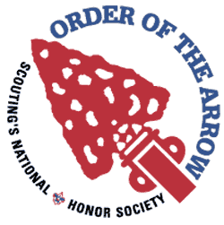
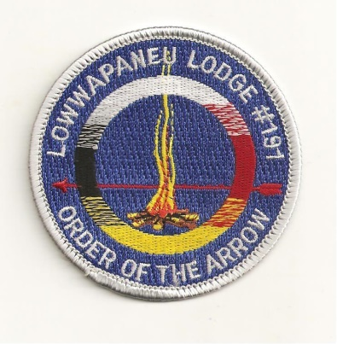
Lowwapaneu Lodge 191 - Section NE - 5
GLM Minutes
November 23, 2016

1. Call to Order, Pledge and Obligation – 7:30
2. Roll Call
3. Secretary’s Report - Motioned by: 1st Ben Sebring 2nd JC Norvilas
4. Treasurer’s Report - Motioned by: 1st Chris Gowarty 2nd Robby B
5. Vice Chief Of Administration’s Reports
a. Camping- Promotional Video is almost done, and should be shown at the Holiday Banquet.
b. Communications- Almost done with the next edition of smoke signals
c. Brotherhood- Looking forward to the upcoming events
d. Service- Nothing new to report
6. Vice Chief Of Program Reports
a. Activities- Nothing new to report
b. Elangomat- Looking forward to the upcoming election season, and working on the Extended Elangomat Program.
c. NAA- Thank you everyone that came and helped out at HarvestFest, more information will be out soon.
7. Chief’s Report
a. Food- Currently planning for the upcoming Ordeal
b. Ordeal- Currently reading the evaluations from the Spring Ordeal and working to make the next Spring Ordeal outstanding.
c. Unit Elections- Looking forward to the Unit Election Training on December 4th and the upcoming election season.
e. Ceremonies- We had a total of 10 members help out with ceremonies this year, thank you everyone that helped out this year. Looking forward to the upcoming activities.

8. Old Business
- HarvestFest- On October 22 and 23 Lowwapaneu Lodge helped out with the Council’s annually HarvestFest. Over 1,000 Cub Scouts attended. Lowwapaneu Lodge hosted a Native American Village, and helped out with various things.

- Last COC- Our Lodge will be hosting the 2020 Conclave, hosting all eleven lodges at Goose Pond Scout Reservation.
9. New Business

- Unit Elections Training- we will be having our Unit Elections Training on December 4th at the Scout Service Center, more information will be out soon.

- Holiday Banquet- Come on out to our Holiday Banquet which is going to be on Dec-28th. There will be a ton of fellowship, no cheerful service. There will also be patch auction at this event and also the new lodge officers will be sworn into office. More information will be out soon.

- Vigil Nominations- Vigil Nominations are due by December 1st , this form is also on the Lodge Website, and you can also hand in this form at the Scout Service Center.

- January LLD- Lodge Leadership Development which we will be held on January 13th more information about this event will out soon.

- Merit Badge College- Lowwapaneu Lodge will be helping out with Merit Badge College at Kings’s College on January 7th. We are currently looking for a chairman, so if you are interested in becoming the chairman please e-mail one of the Lodge Officers.

- Smoke Signals- We are currently working on the next edition of Smoke Signal and we are looking for articles from each chairman. If you are interested in putting an article in you can e-mail Joe Norvilas.

- Adopt-A-Highway- Postponed to a later date, look out for more information.

** Officer Elections**
The 2017 Lodge Officers
Lodge Chief- Matt Smith
Vice Chief of Program- Zach McDonough
Vice Chief of Admin- Joshua Lawler
Secretary- Joe Norvilas
Treasurer- Wyatt Sebring

10. Good of the Order

11. Lodge Officers’ Comments

12. Lodge Adviser/ Staff Adviser Comments

13. Adjourn- 9:20

