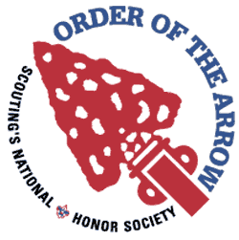
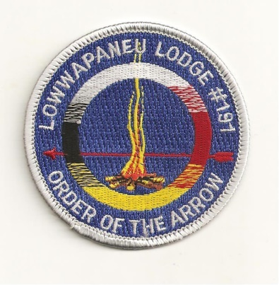
Lowwapaneu Lodge 191 - Section NE - 5
LEC Minutes
October 26, 2016

1. Call to Order, Pledge and Obligation –
2. Roll Call
3. Secretary’s Report - Motioned by: 1st JC Norvilas 2nd Ben Sebring
4. Treasurer’s Report - Motioned by: 1st Chris Gowarty 2nd JC Norvilas
5. Vice Chief Of Administration’s Reports
a. Camping- Not Present
b. Communications- Currently working on the new edition of smoke signals, and in need of more articles. Also updating the Lodge Website
c. Brotherhood- Not Present
d. Service- Adopt-a-Highway this Sunday @ 2 at Goose Pond Scout Reservation.
6. Vice Chief Of Program Reports
a. Activities- Not Present
b. Elangomat- Not Present
c. NAA- Harvest Fest went over Great, Thank you for all that came and helped out. The next NNA committee meeting will be on Tuesday @ 7 at the Scout Service Center.
7. Chief’s Report
a. Food- Nothing new to report
b. Ordeal- Nothing new to report
c. Unit Elections- Currently looking forward to upcoming election season. The unit election training will be coming up in December.
e. Ceremonies- Nothing new to report

8. Old Business
- HarvestFest- On October 22 and 23 Lowwapaneu Lodge helped out with the Council’s annually HarvestFest. Over 1,000 Cub Scouts attended. Lowwapaneu Lodge hosted a Native American Village, and helped out with various things.

9. New Business

- November GLM/ Elections- November General Lodge Meeting which will be held on Nov 23rd at the Scout Service Center, we will be voting for the 2017 lodge officers. If you would like to run for lodge office, feel free to email one of the officers for more information.

- Unit Elections Training- we will be having our Unit Elections Training on December 4th at the Scout Service Center, more information will be out soon.

- Holiday Banquet- Come on out to our Holiday Banquet which is going to be on Dec-28th. There will be a ton of fellowship, no cheerful service. There will also be patch auction at this event and also the new lodge officers will be sworn into office. More information will be out soon.

- Founder’s Nominations- Founder’s award nominations are due by November 1st, you can find the form on the Lodge Website and you hand this form in at the Scout Service Center.

- Vigil Nominations- Vigil Nominations are due by December 1st , this form is also on the Lodge Website, and you can also hand in this form at the Scout Service Center.

- January LLD- Lodge Leadership Development which we will be held on January 13th more information about this event will out soon.

- Adopt-A-Highway- We are planning on a road side clean up at Goose Pond Scout Reservation on October 30th at 2PM

- Merit Badge College- Lowwapaneu Lodge will be helping out with Merit Badge College at Kings’s College on January 7th. We are currently looking for a chairman, so if you are interested in becoming the chairman please e-mail one of the Lodge Officers.

- Smoke Signals- We are currently working on the next edition of Smoke Signal and we are looking for articles from each chairman. If you are interested in putting an article in you can e-mail Joe Norvilas.

10. Good of the Order

11. Lodge Officers’ Comments

12. Lodge Adviser/ Staff Adviser Comments

13. Adjourn- 8:30

